*Decision Tree Regressor*

Regression ke case mai how it works

Ki sbh same hota bss

Impurity Function change hota hai jo ki hota hai MSE

**Subject vale column ke base pe split ( Binary Classification )**

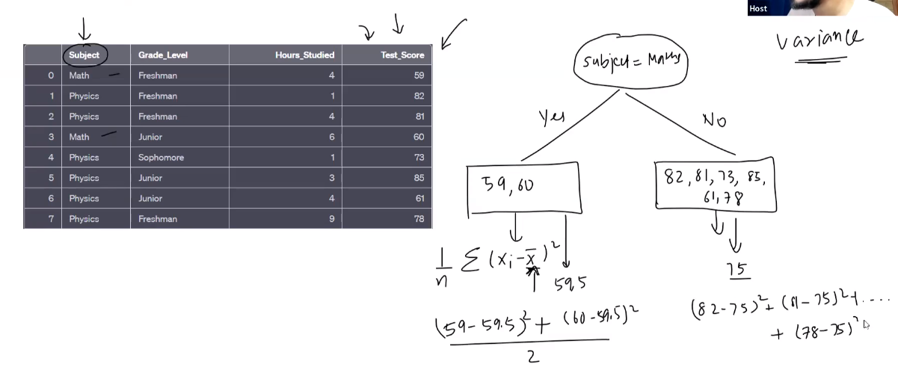

Ese hum yes & no

Dono ka alag alag variance nikalte hai then

Overall Variance nikalte hai

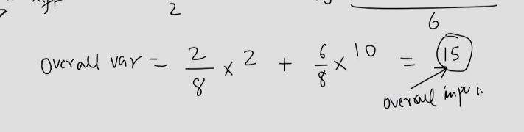

It gives us overall impurity

**Multiclass**

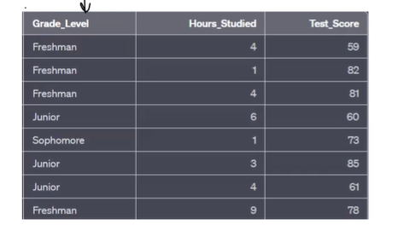

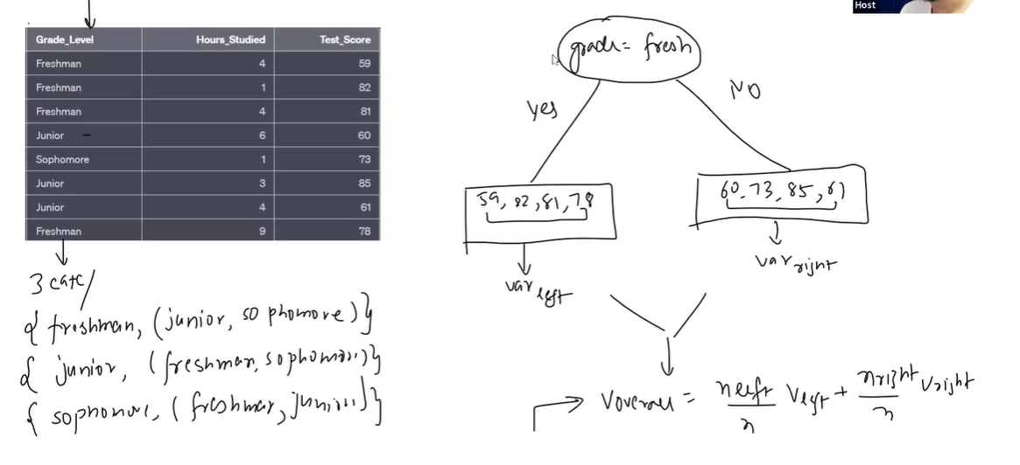

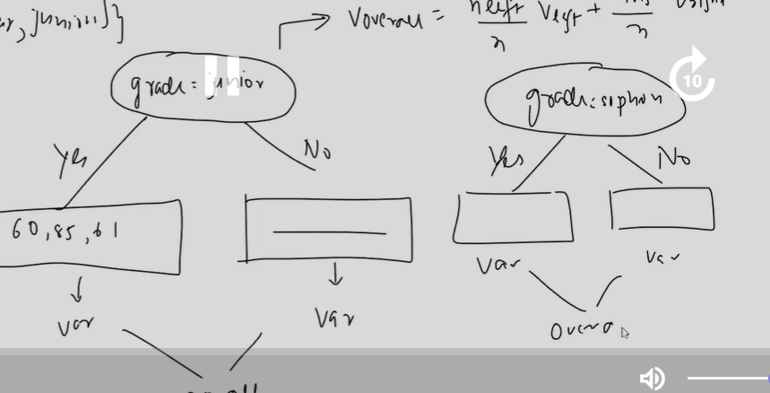

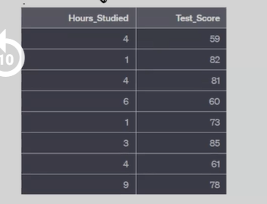

Numerical value ke time unhe sbhse pehle hum Sort karlete hai

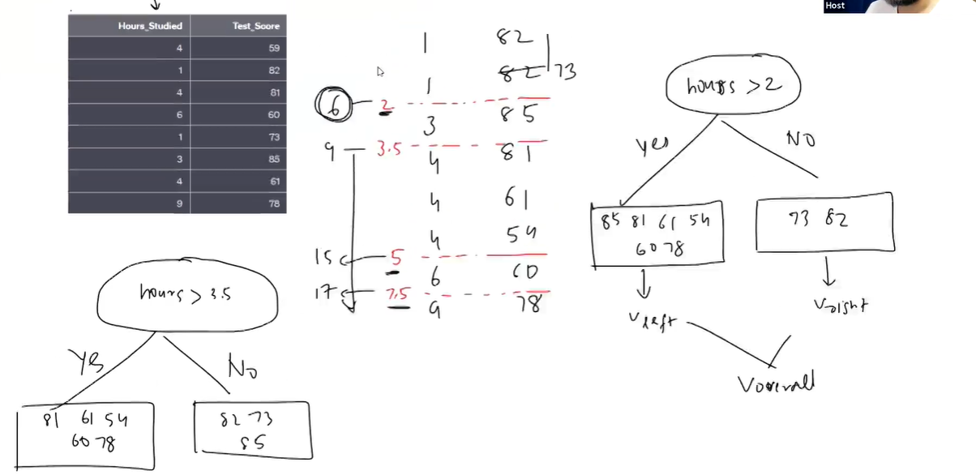

Esehie jiska sbhse kamm value aarhi hogi tou ushiko hum threshold maanlenge

Hum root node sbhse kamm vale ko banayenge